1.6 Review Game
Use white boards to do the following problems.

1. 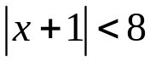 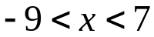

2. 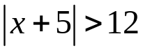 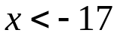 or 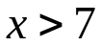

3. 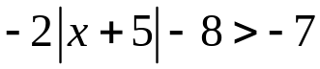 No Solution

4. People typically live to be between 75-85 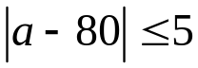
years old. Write an absolute value inequality
that represents the typical lifespan of a person.

5. Define absolute value.

Jeopardy
 | Solving  Absolute Value Equations | Graphing | Absolute Value Inequalities | Visual | Mystery
100 | 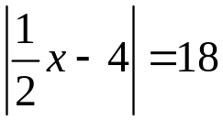 | 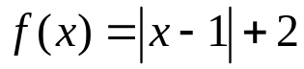 | 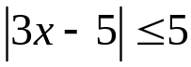 |  | Find the vertex:  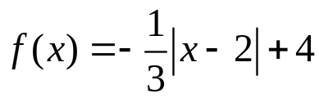
200 | 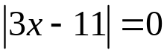 | 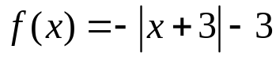 | 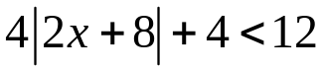 |  | Solve:  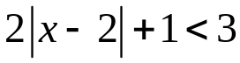
300 | 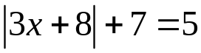 | 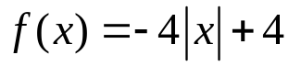 | 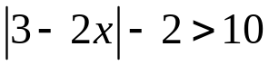 |  | Solve:  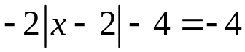
400 | 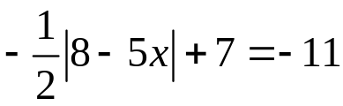 | 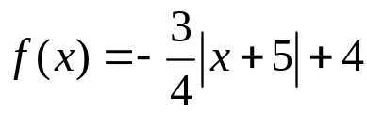 | 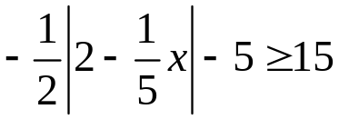 |  | Solve:  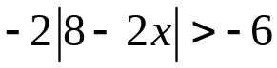
500 | 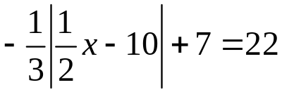 | 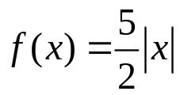 | 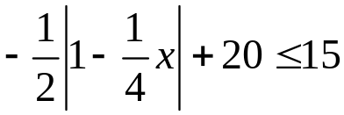 |  | Write the equation:

Visual:
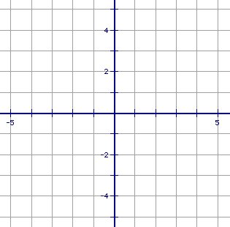
1. 3. 5.

2. 4. 6.

Jeopardy
 | Solving  Absolute Value Equations | Graphing | Absolute Value Inequalities | Visual | Mystery
100 | x=44 or  x=-28 | Vertex: (1, 2)  x=1  up | 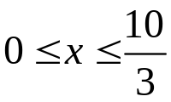 | 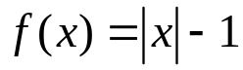 | Find the vertex:  Vertex: (2, 4))
200 | 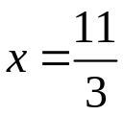 | Vertex: (-3, -3)  x=-3  down | 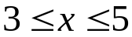 | 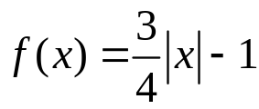 | 1 < x < 3
300 | No Solution | Vertex: (0, 4)  x=0  down | 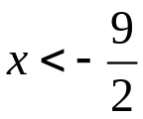 or  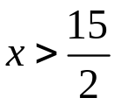 | 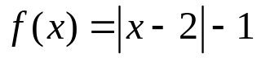 | x = 2
400 | 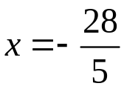or 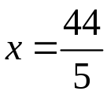 | Vertex: (-5,4)  x=-5  down | No Solution | 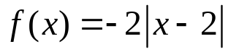 | 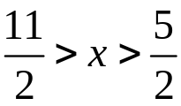
500 | No Solution | Vertex: (0, 0)  x=0  up | 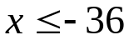 or  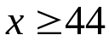 | 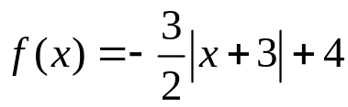 | 